SAPTHAGIRI COLLEGE OF ENGINEERING
(Affiliated to Visvesvaraya Technological University, Belagavi& Approved by AICTE, New Delhi.)
(Accredited by NAAC with ‘A’ Grade) (ISO 9001-2015 & 14001-2015 Certified)
#14/5, Chikkasandra, Hesaraghatta Main Road, Bengaluru– 560 057
Department of Computer Science and Engineering
Accredited by NBA
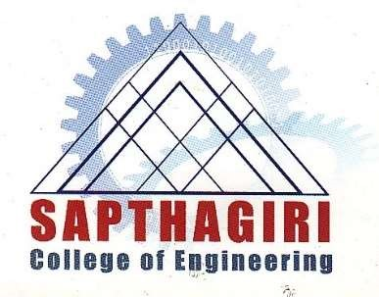
Certificate

Certified that the technical seminar entitled “Practical Algorithm Substitution Attacks on Real-World Public-Key Cryptosystems” carried out by Shravan L bearing the USN 1SG20CS100, a bonafide student of Sapthagiri college of engineering in the partial fulfillment for the award of Bachelor of Engineering degree in Computer Science and Engineering of Visvesvaraya Technological University, Belagavi during the academic year 2023-2024. It is certified that all corrections/suggestions indicated for internal assessment have been incorporated in the report. The technical seminar report have been approved as it satisfies the academic
requirement in respect of technical seminar (18CSS84) prescribed for the said degree.

Signature of the Guide Signature of the HOD
Prof. Lavanya K Dr. Kamalakshi Naganna
Assistant Professor Professor & Head

